GROUP PROJECT PROPOSAL

FRAMEWORK-BASED PROGRAMMING

Junk Food Sedap

JFS Team

Juan Carlos Tepanus Pardosi 05111942000017

Salma Rahma Lailia 05111942000016

Farah Dhiah Qorirah 05111942000018

DEPARTEMEN TEKNIK INFORMATIKA

FAKULTAS TEKNOLOGI ELEKTRO DAN INFORMATIKA CERDAS

INSTITUT TEKNOLOGI SEPULUH NOPEMBER 2022

# A. Application Background

Technological advances are very closely related to our daily lives today. Technology makes tasks easier. Many innovations have been made and new styles have emerged to perform daily activities using ever-evolving technology. Over time, mobile phones have also developed as a communication tool to send messages to others without having to go back and forth between space and time. The Internet supports viewing various types of information quickly, both domestically and internationally. From there you can do it overseas.

The internet connects all of us and helps us access any information anytime, anywhere. Therefore, some people believe that the internet needs to be fulfilled to support their daily activities. The number of internet users in Indonesia is increasing rapidly from year to year, reaching a maximum of 84 million in 2017. After that, Indonesian Internet users increased by 13.3% to 92.5 million in 2018, and the number of Internet users increased to 12.6% in 2018. 2019, reached 107.2 million compared to 2018. (Statista, 2019). You can also experience internet technology on mobile phones known as smartphones. With only one thing, we can do what we want to do. Activities such as online payments and order delivery. Delivery orders are one of the most popular food delivery services, especially during the current pandemic.

This service makes it easier for consumers to buy necessities and helps most modern people who prefer to order groceries at home instead of buying directly from restaurants, increasing company sales. Based on the background discussed and the existing phenomena, Our team is interested in creating a “Junk Food Sedap” website related to purchasing decisions for online grocery delivery. Delivery of food order data using MySQL as the database management system and phpMyadmin is used to connect the database.

# B. App Description

This application aims to provide online food ordering and delivery. Here is the User Story of this application:

* As a user, I want to buy food online, so I don't waste time waiting in line.
* As a user, I want my food to be delivered to my home, so I don't meet a lot of people during the current pandemic.

# C. Application Benefits

Relevant to the purpose of our application, some benefits can also be felt by users such as:

1. Easier to reach

Because the system of our application is delivery, it is certain that consumers no longer need to find it difficult to find a store location. Users only need to see the menu on the website and order it then the food will be delivered by the driver.

1. Faster transaction

Another benefit that can be obtained is that transactions made will be faster.

So the service will run faster.

1. Sales will be wider

For restaurants or cafes that implement this application, their sales can certainly be wider. People from a certain distance will be able to buy food from restaurants without the need to know where it is. Because this delivery system will make it easier for restaurants to reach consumers who are farther away.

1. Maintain health

As a form of our concern for the current pandemic, this application can be an alternative for restaurants to keep getting increased sales because all the processes are done online.

Our application will be very useful as an alternative to a restaurant to expand marketing and increase sales. In today's modern era, everyone will prefer things that are simple and effective. Facing that, the Junk Food Sedap Application is one of the creative implementations of changes in modern times. What's more, during this pandemic, social distancing and avoiding crowds are things we must obey. Therefore, so that consumers can get their food needs while still following the protocol, using the Junk Food Sedap Application is a solution.

# D. Application Features

1. Login Page

Before ordering food, customers are required to have an active account. In creating an account, customers are asked to fill in their data along with the email used to log in.

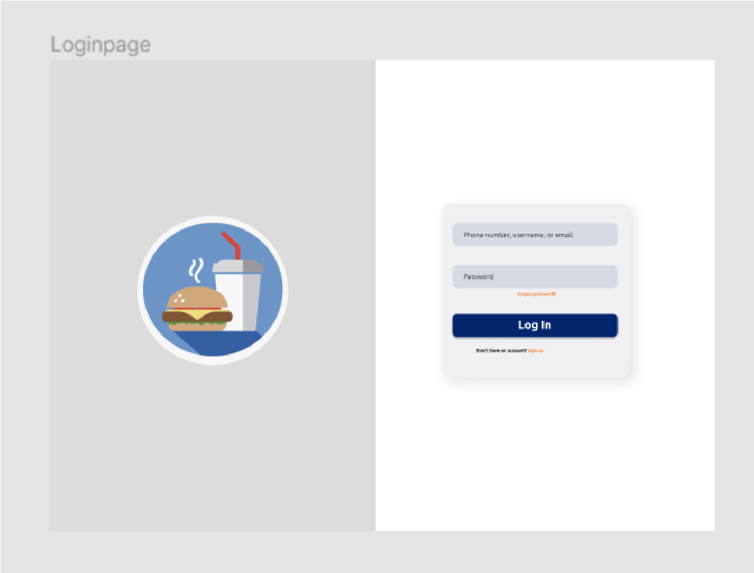

1. Home Page

On this home page, there are all the menus along with the prices provided and can be ordered by the customer. On each menu, there are food descriptions that are useful for making it easier for customers to order.

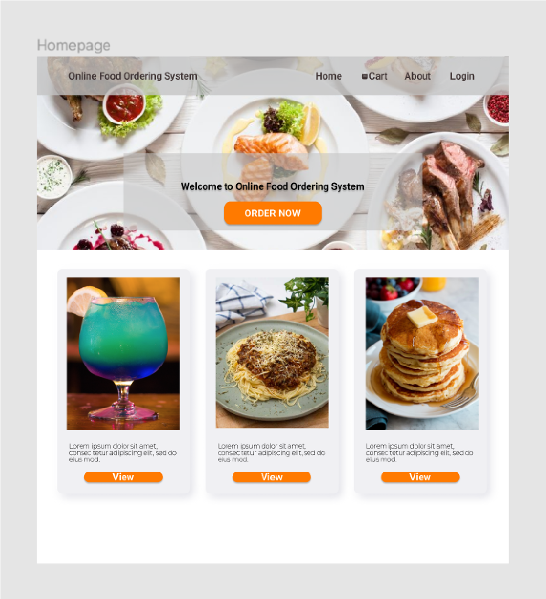

1. Waiting List

This page contains various menus that have been selected by the customer and are ready to be checked out. This waiting list aims to ensure which menus will be ordered by the customer so that there are no ordering errors.

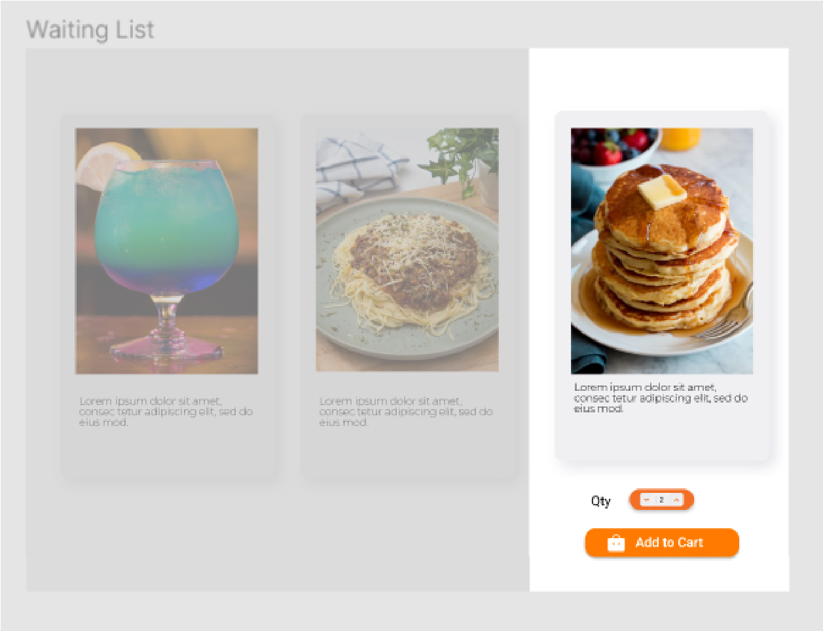

1. Cart

All foods that have been checked out will appear on this page.

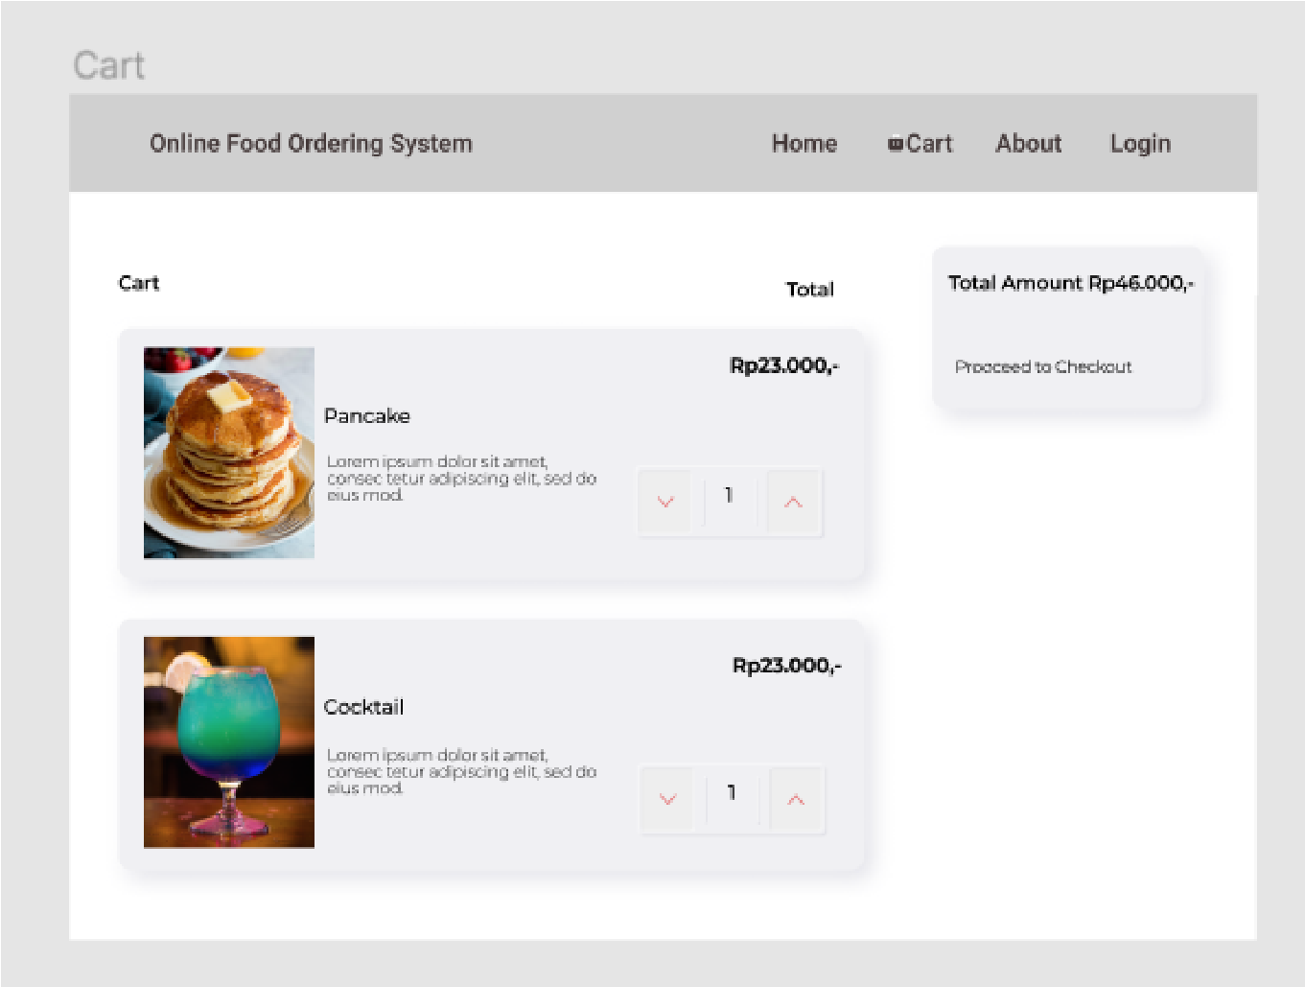

# E. Application Architecture

1. Flow Chart Diagram

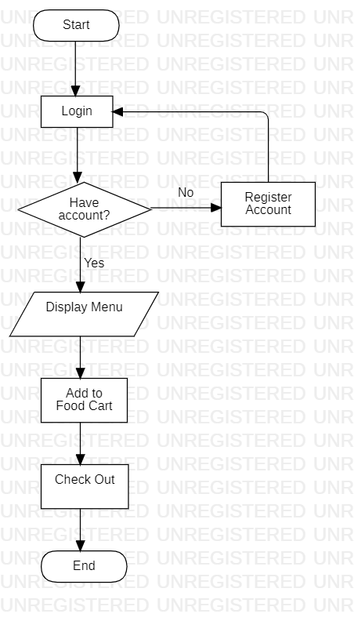

1. Activity Diagram

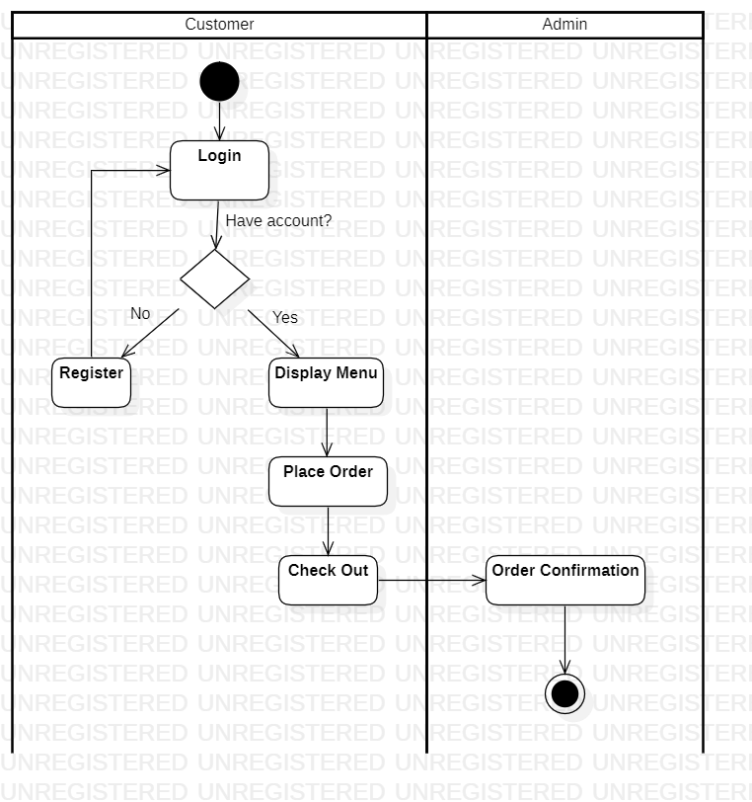

# F. Technology Used

To operate our database, we use MySQL as the database management system and phpMyadmin is used to connect the database. The designs we use are using HTML, JavaScript, Bootstrap, and Laravel as our framework. For the library, we need more time to think in detail but maybe we can add some basic library to generally build a website like “maatwebsite/excel”, uxweb/sweet-alert": etc. The ideas for the library come up from the references that we have seen in google, here is the link as follow; [https://karyakarsa.com/debrianruhut/web-dev-instalasi-framework-laravel-dan-librar y-dasar](https://karyakarsa.com/debrianruhut/web-dev-instalasi-framework-laravel-dan-library-dasar).

# G. Team Work Division

* Juan Carlos Tepanus Pardosi Back-End
* Salma Rahma Lailia Front-End
* Farah Dhiah Qorirah Back-End